The Government PU college, Rajanakunte

The Government PU College, Rajanakunte, Bangalore, Karnataka, has been a part of the educational landscape since 2020. Encompassing 3.15 acres, it is currently undergoing a transformative project supported by Manyata Embassy, with an investment of 4 crores. The college offers diverse courses in Arts, Commerce, and Science.

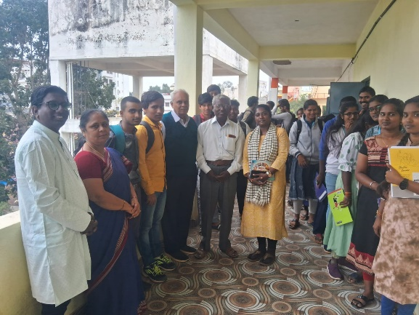  
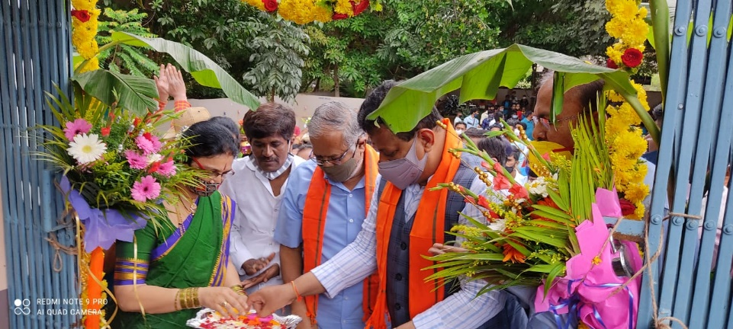

The Government High School, Rajanakunte

Established in 2009, the Government High School in Rajanakunte, Bangalore, Karnataka, sprawls across 4.5 acres. This institution provides education for 9th and 10th grades in both Kannada and English mediums.

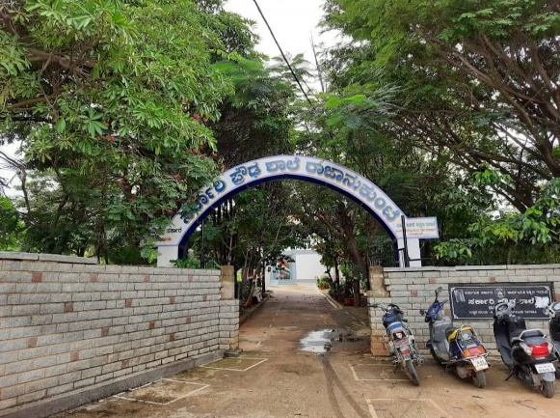

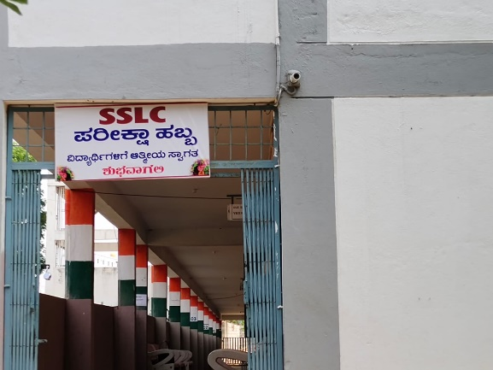

The Government Primary School, Rajanakunte

The Government Primary School in Rajanakunte, Karnataka, traces its roots back to 1945. Nestled on a 3-acre expanse, it caters to students from Std 1 to 8. The medium of instruction for Std 1-5 is Kannada, while for 6th-8th, it extends to both Kannada and English.

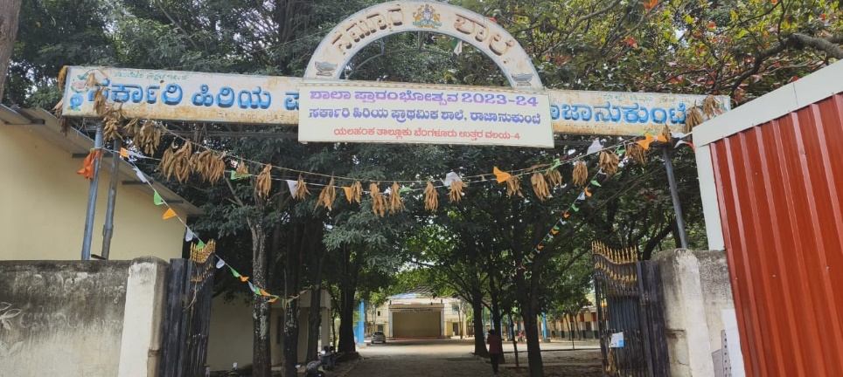

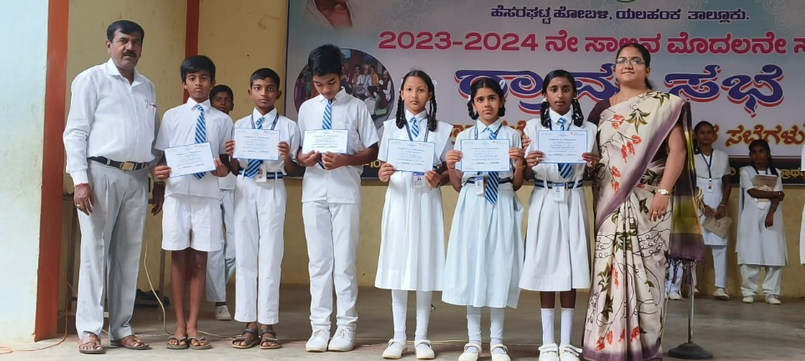

Additional photos:

